This document was part of a project done for a technical writing class. It has been posted at www.foolfactor.com/lab/doc as a free reference guide for any who may come across it.

You may email me, the author, at dan at foolfactor d o t com.

-- Note: For a plain vanilla checklist, perhaps for printing, simply change the view to the OUTLINE view.

Equipment

Overview

Creating an equipment list is one of the most helpful and stress-reducing things you can do for yourself once you have decided on a place to camp. Nobody likes it when the question, “Did anybody bring toilet paper?” is met with silence during a five mile hike. It is not be a bad idea to start making your camping list as you read through this section. The following topic areas will be covered in this section:
- Shelter
- Clothing
- Lighting
- Medical
- Personal Hygiene
- Food and Water
- Exploring
- Entertainment

The Boy Scout motto to “be prepared” is worthwhile to keep in mind when packing for your next camping trip. A smart way to protect against unforeseen circumstances is to bring along some extra cash. This is especially useful when you inevitably realize you forgot your toothbrush, or you notice your canteen is leaking. Organization while packing, such as storing all cooking supplies in one large bin, is helpful for saving yourself from the headache of trying to locate items you need when you finally reach camp later than expected and you have to setup in the dark. It is also not a bad idea have a toolbox in your car, along with extra fan belts for any car problems.
Figure 46: Packed and ready for adventure.

Shelter

Tent
- Tent: When picking out a tent you need to be concerned about the color of your tent, because bugs will be attracted to black tents as well as brightly colored tents (Wright). The other main considerations are: will it keep my dry, how hard it is to put up, how roomy it is, and if you are a backpacker: how much it weighs.
Figure 47: Your only protection from the rain as you sleep.
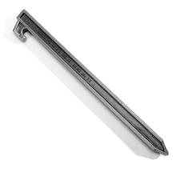
- Extra stakes: The skinny aluminum stakes that come with most tents are usually too fragile. You are better off purchasing heavier duty stakes
- Mallet: Used for pounding in those solid stakes.
- Seam sealer: This should be applied to the seams of the tent before the trip to help prevent water from seeping in.
- Sportsman’s goop: Rubbery gel that can temporarily and quickly seal up leaks discovered in your tent when the rain pays you a visit.
Figure 48: A good, solid stake will keep your tent from blowing away.

Hammock
- Hammock: A lightweight option to sleeping in a tent.
- Extra rope: In case the only available trees are far apart.
- Tarp: To keep it rain and morning dew from soaking you while you sleep. This will also provide a nice area to store your equipment.
- Mosquito net: Even though there are not many bugs in Oregon, there still usually are enough to make it difficult to sleep without one.
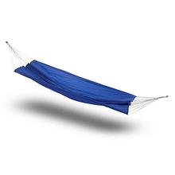
Figure 49: Hammocks are darn comfortable for sleeping in.

Sleeping
- Sleeping bag: Down sleeping bags offer more warmth per pound than synthetic bags, and can also be compressed tighter. Synthetic bags on the other hand are usually cheaper and do not last as long, but they will keep you warm when wet.
- Cot: If you are car camping this can be quite a comfortable alternative to sleeping on the ground if you didn’t bring a hammock.
- Padding: You can use inflatable mattresses but the ones that you would usually see at the pool will draw heat from your body because of the large space for air flow inside of it. You can combat the heat loss by placing a foam mat over the mattress. An even better solution is to use a combination foam mattress, such as a self-inflating Therm-a-Rest brand pad.
- Pillow: A bunched up coat or sweatshirt usually works well as a substitute for a pillow if storage space is limited.
- Sheets and blankets: In the summertime a sleeping bag might be too warm, so you would want to simply use a sheet or light blanket instead. At other times, perhaps around the campfire, a fleece blanket can be quite helpful.

Other Items
- Fold up chairs.
- Umbrella.
- Large tarps: To create dry places to hang out, or for storing gear.
- Twine and bungee cords: For securing the tarps.
- Duct tape: To repair tents or tarps.
- Shovel: You may need to dig a latrine or perhaps a fire pit.
- Rake.

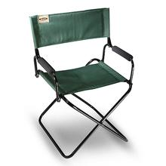
Figure 50: This chair is folds up into an amazingly small package.

Clothing

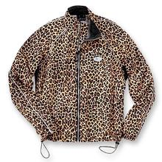
General Tips
Layering is important when selecting clothes. When you plan for wearing several layers you can make better use out of the clothes you bring, and not end up bringing a lot of extra weight due to over-specialized items. For example, instead of bringing a very thick winter coat, instead bring a waterproof unlined jacket, and then bring long underwear or fleece linings as necessary.
You do not want to wear bright and flashy clothes, or else you will catch the attention of all the insects as well.
Never wear cotton on your body in a place where it could get wet from rain or sweat. Cotton offers little warmth when wet, and takes a long time to dry. Synthetics dry quicker and keep you warmer when wet (Wright). For long underwear polypropylene works great at wicking dampness away from your skin (Stienstra, 24).
Figure 51: Bring a light jacket that blends in well with the sand dunes.
- Bins or plastic bags: For keeping your clothing dry, and providing a place to store your dirty clothes as well. If you have younger children it is a good idea to pack each one of their outfits in a separate bag to make it easier for them.
- Sewing kit.
- Rope: For a clothesline.
- Sunglasses.
- Poncho or Rain coat. Since these items are fully waterproof, they are also air-tight, so be sure to search for ones that provide some sort of ventilation flaps.
- Hat: A simple baseball cap will keep the sun out of your eyes, or a Gore-tex hat will keep your whole head dry from rain.
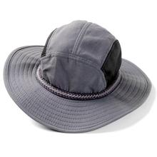
Figure 52: Hats offer great protection from rain and sun.

Feet
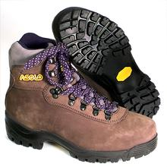
- Hiking boots: They are necessary for long hikes, or even shorter ones on rugged trails, because they will help prevent twisted or rolled ankles.
- Galoshes.
- Casual sneakers.
- Extra socks: Remember not to bring cotton socks! A good combination is to usually have a thin poly-blend sock liner, and then a thicker wool sock outside of it.
- Sandals.
- Gaiters: These are useful for when there is snow on the ground. They are like bottoms of snow pants; attaching snugly to your boots and cinching up around the top of the calves.
Figure 53: When climbing the coastal mountains you should wear rugged hiking boots.

Lighting

Electricity Based
- Flashlight.
- Headlamp: You do not need to wear large and heavy mining-style headlamps these days, because there are new lightweight halogen based lamps. These are commonly referred to as ‘Petzel’ lamps, because that is the name of the company that has been developing them. They are extremely bright for their size.
- Lantern: Some of the battery powered lanterns out there come with handy remote controls, which are great for trying to locate it at night.
- Extra batteries: If you are concerned much with the weight of your equipment you should use lithium batteries. Lithium batteries provide twice as much power as alkalines, and weigh half as much (Wright).

Gas Based
- Propane lantern: Be careful around these, they can get quite hot.
- Lantern hanger: These provide a safe place for hanging lanterns. You usually wrap a chain around a large tree, and a metal hook hangs from it that holds the lantern.
- Extra mantels.
- Extra fuel.
- Candles.
- Waterproof matches.
- Match container: You can use old film canisters or Ziploc bags for keeping matches dry.
- Lighter.

Campfire

Fires are not allowed in large driftwood piles or against large logs on Oregon’s beaches (Sullivan, 9).

- Wood: Since some of the more popular campsites might not have much dry, dead wood laying around due to others making fires, you might have to pick up a bushel of wood from a nearby store if you wish to have a campfire.
- Saw, hatchet or maul: For cutting up your firewood.
- Water bucket or fire extinguisher.
- Leather gloves.

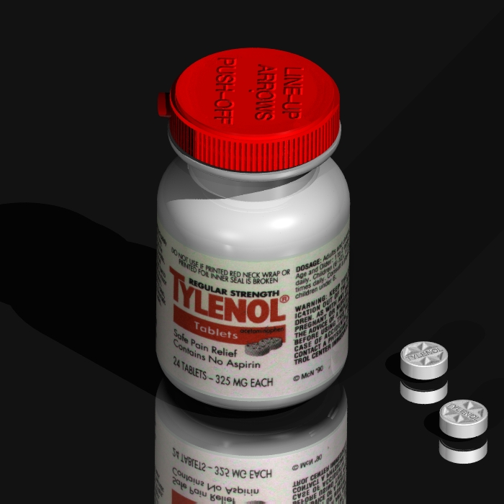
Medical

- Sunscreen.
- Chapstick.
- Bug repellant.
- Prescription medications: Don’t forget your pet’s medications as well!

First Aid Kit
For more information about safety and first aid consult the safety section.

- Emergency blanket.
Figure 54: Tylenol will help you cope with the soreness from a long hike.
- Thermometer.
- Pain relievers.
- Tweezers: They are the tool to use for removing ticks and splinters. Do not try to remove ticks by burning them or smothering them in Vaseline (Stienstra, 44).
- Antiseptics: Rubbing alcohol is not only good for sanitizing, but it works great for removing sap from your hands.
- Band-aids.
- Moleskin: It is used to treat blisters. It is a thick donut shaped material that you place around the blister to help keep pressure off of it so it can heal.
- Large bandages: Feminine pads can double quite nicely as bandages, because they are sterile and are great at absorbing liquids.
- Tape for the bandages.
- Diarrhea pills.
- Benadryl or calamine lotion: Unfortunately poison oak lives in the woods of Oregon.

Personal Hygiene

- Deodorant: Avoid perfumes and scented deodorants, unless you want the bugs to mistake you for a flower. Since most deodorants contain aluminum they can reduce the allergic reactions to a bee sting by rubbing it on the sting (Stienstra, 27).
- Soap: Try to get biodegradable soap, which will pollute less than regular soap. An even better product is the instant hand sanitizer gel, which will not pollute at all!
- Shampoo and conditioner: Remember that you want to try to get mildly scented items!
- Shower cap.
- Large plastic container with spout: Can be used for showering with if there are not going to be any showers where you will be camping. If you brought along a large pan and have a roaring fire, you might even be able to shower with warm water.
- Cloth towels.
- Paper towels: They are great for a quick clean up, and then can be thrown right into the fire.
- Toothbrush.
- Toothpaste.
- Floss.
- Razors and shaving cream.
- Toilet paper.
- Feminine products.
- Diapers.
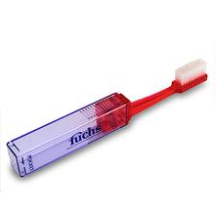
- Baby wipes: They also work well as makeup removers and facial cleansers.
- Comb and brush.
- Mirror: It is safer if you can find a mirror that is metal instead of glass, such as an emergency signaling mirror.
Figure 55: A convenient travel sized toothbrush.

Food and Water

Storing Food and Water

- Zip-loc bags: Small and large sizes.
- Aluminum foil: It also works great for cooking food in as well.
- Bins or extra backpacks: Place all your food into bags or bins, and then keep it away from the campsite so that animals will not bother you at night.
- Rope: Use rope with the storage containers to hoist them up high into the trees where bears will not reach them.
- Water bottles and canteens: Empty two liter bottles work quite nicely for storing water.
- Large water container with spout: To make refilling bottles and washing hands easier.
- Water bladder: A plastic bladder that sits in your backpack with a rubber tube coming out around to the front to make drinking water quick and easy. You can buy a Platypus brand unit, or make your own from pvc tubing and empty two liter bottles. You simply drill a hole in the bottle cap, and shove the tube through.
- Cooler.
- Ice for the cooler.

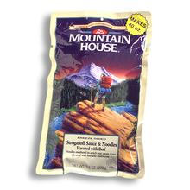
Food
You can buy complete freeze-dried meals that are quick and easy to make, but they come at a hefty price. There is everything from beef stroganoff to brown rice and chicken. To save money but still have the convenience of dehydrated foods, you can make your own meals from foods such as dehydrated milk and eggs. Macaroni and cheese boxes, instant soups and instant oatmeal and instant coffees and drinks are also great camping foods. Along with your main courses you will want to probably include the following items on your checklists:
- Spices.
- Condiments.
Figure 56: With freeze-dried stroganoff dinners you eat them right out of the bag.
- Drink mixes.
- Trail mixes.
- Jerky.
- Pet food.

Water
The average hiker needs to consume at least a quart of water a day (Sullivan, 10). When the weather is warm, it is nice to have ice water during your campout, which can be done by freezing extra containers of water before you leave home. If plan on using water from streams, you must be sure to purify it first. You can purify water by boiling it for five minutes, or by using the following items (Sullivan, 9):

Iodine can be harmful to people with thyroid problems (Wright).

- Water pump and filter.
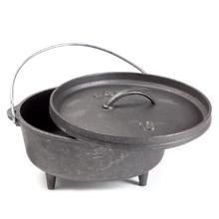
- Iodine tablets.

Cooking
- Measuring cups.
- Potholders.
- Cutting board.
- Spatula.
- Barbecuing utensils.
- Flatware.
- Paper towels.
- Table cloth.
- Wine cork puller: Most camping multipurpose knives already have these.
- Can opener: Also can be found in many camping knives.
Figure 57: A dutch oven. Visit http://www.mikebentley.com/camping for some great dutch oven recipes.

- Pots and pans.
- Dutch oven: A heavy cast iron pan with legs and a lid that sits right in the coals of your fire. Many different exquisite dishes can be made with this mini oven.
- Camping stove: You never want to buy a stove that uses kerosene, because it is smelly, messy, provides little heat, and requires priming. Stoves that use white gases, propane or butane are most desirable. If you will be camping when it is very cold out you might not want to use butane fueled stoves because the fuel will not evaporate as well as propane would even though butane weighs less than propane (Pearson, 32).
Pot and pan materials:
- Aluminum: Light, cheap, conducts heat well, dents easily.
- Stainless steel: Hardier and more scratch resistant.
- Titanium: Very light, very strong, uneven heating, expensive.
- Non-stick coated: Easy clean up, least durable.

- Coffee maker.
- Coffee filters: They can be used to filter the sediment out of water as well.

Eating
Do not clean your dishes in streams!
You will contaminate both the stream and your dishes (Wright).

- Flatware.
- Serving utensils.
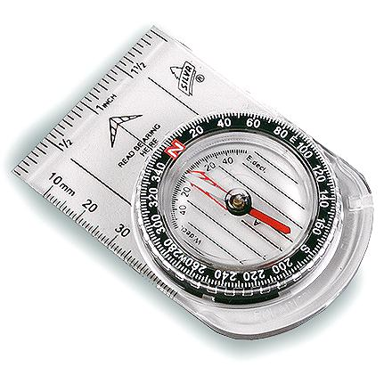
- Paper towels: Much more useful than napkins due to their size and absorbancy.
Figure 58: An orienteering compass.
- Plates: Paper plates can make clean up quite easy with a campfire.
- Bowls.
- Cups.

Cleaning
You can help reduce pollution by employing mother nature to help clean your dishes. You can clean with dirt, sand or gravel, and wipe out your dishes with grass. When you rinse your dishes be sure to use clean water.
- Soap: Try to use biodegradable soap if possible, it will cause less harm to the environment.
- Scrub pad.
- Deep pans: To hold the water for cleaning and rinsing your dishes.
Using a map and orienteering compass in Oregon:
(Refer to figure 58.)
The red arrow in your compass points to magnetic north which is not always the same as true north. On the Oregon Coast magnetic north is roughly 18 degrees to the east of true north. In order to setup your compass to point to true north in Oregon, you simply have to turn the rotating part of the compass (the bezel) clockwise 18 degrees (each small mark usually is two degrees on your compass). You compass should now be set to 342 degrees.

This is important to do because the vertical lines in most maps are pointing to true north. Now you will be able to figure out which way to turn the map.

The first step is to place the compass on the map, with the left or right side of the compass lined up with a vertical line on the map. While holding the map and compass together, rotate everything around until the red arrow is lined up with the arrow underneath it, and also should be pointing at the N on your bezel. Now you will be holding your map lined up with true north!
- Plastic garbage bags.

Exploring

Finding Your Way
- Compass.
- Road map.
- Trail map.
- Topographical map: A map that shows the contours of the land. It is useful for identifying cliffs areas and steep trails.
- Highlighter: To mark the maps.
- Pen and paper.
- GPS unit. A satellite linked global positioning unit. It shows you your position relative to points you have chosen to remember. Some will automatically map out your path.

Getting Help
- Signal mirror: Used when you are lost by reflecting light from the sun toward a search party, such as a helicopter.
- Whistle.
- Cell phone: Digital cell phone service usually is not available far from civilization, but you might be able to have analog reception.
- CB radio.
- Antenna: To help expand the range of your CB or cellular phone you can use a car-mounted antenna.
- Extra batteries.
Figure 59: The differences between an external frame backpack on the left, and the internal frame on the right are not that extreme.
Other Essentials
- Backpack: There are two main kinds of backpacks, internal frame and external frame. External frames are better at keeping your body cool by letting more air flow between your back and the pack. Internal frame backpacks are much more popular these days, as they stick closer to your body which is important if you explore rough terrain. If do wont be taking any hikes where you will need lots of equipment, then a simply day-pack (like would used for school) would be better suited.
- Fanny pack: A pack that goes around your waist and provides quick access to your water bottles, because most of them contain water bottle holder or two.
- Walking stick.
- Watch.
- Binoculars.
- Telescope.
- Camera.
- Film.
- Extra battery.
- Multipurpose knife.
- Baby stroller.
- Baby carrier.

Entertainment

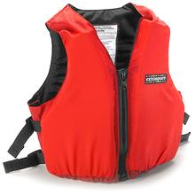
By the Water
Figure 60: Staying safe while boating means wearing a life jacket.
- Beach towels.
- Beach blanket.
- Beach umbrella.
- Toys for playing in the sand.
- Buckets.
- Kites.
- Volleyball and net.
- Frisbee.
- Soccer ball.

In the Water
- Tide table. Pick one up from a local store or visitor center for free.
- Dry suit or wet suit: The ocean on the Oregon Coast is always very cold.
- Surfboard.
- Bodyboard.
- Windsurfing equipment.
- Life jackets.
- Inflatable water toys.
- Water guns.

Getting Around
- Bike.
- Bike tire repair kit.
- Tire pump.
- Scooter.
- Skateboard.
Do you have a good list yet?

By now you should have a good idea of the kinds of things you will need for your trip. If after your trip you find that some items were unnecessary then you can simply make a note of that for the next time you go camping on the Oregon Coast.
- Rollerblades.
- Boat.

Other items
- Portable radio or tv.
- Extra batteries.
- Cards.
- Chalk.
- Travel games.
- Fishing supplies.
- Hunting supplies.

Figure List

46. http://bluethundermovies.simplenet.com/Trailers/Vacation.mov

47 – 53: http://www.rei.com/

54. http://graphics.stanford.edu/courses/cs348b-competition/cs348b-96/

55 – 60. http://www.rei.com/

Bibliography

- Sullivan, William L. (2000). 100 Hikes / Travel Guide Oregon Coast & Coast Range. Eugene: Navillus Press.
- Wright, Bruce. (May 2001). “Car Camping and Backpacking Notes By Bruce.” http://www.corecomm.net/~bw1 (Feb 2002).
- Wright, Bruce. (May 2001). Car Camping Notes. Car Camping and Backpacking Notes By Bruce. http://www.corecomm.net/~bw1/carnote.htm (Feb 2002).
- Wright, Bruce. (May 2001). Backpacking Equipment List. Car Camping and Backpacking Notes By Bruce. http://www.corecomm.net/~bw1/packlist.htm (Feb 2002).
- Stienstra, Tom. (1996) Pacific Northwest Camping. San Francisco: Foghorn Press.
- Pearson, Claudia. (1997). Cookery. Mechanicsburg, PA: Stackpole Books.

